**Commodore VIC-20: Hyper Expander Rev. 2**

**Module Description**

Table of Contents

Introduction 1

Configuration 2

Note 2

DIP-Switches 2

SW3 – EPROM configuration 3

SW3 - Memory Bank Select (EPROM) 4

IC1 Software Size - JP1 4

SW2 – RAM Configuration 5

BYTES FREE 5

EPROMs 6

Using parallel EEPROMs 7

Dimensions 8

Assembly and BOM 8

Full RAM Build 8

No RAM, just EPROM 8

Revision History 8

Rev. 0 8

Rev. 1 8

Rev. 2 9

# Introduction

The Hyper Expander is a cartridge for the Commodore VIC-20, which provides up to 16kB EPROM and up to 37kB RAM. It is a super-set of the original Commodore VIC-1211A Super Expander, which provides only 3k of RAM.

The Hyper Expander can hold up to two 27C512 EPROMs, the 8k memory bank of both EPROMs (A13...A15) can be selected for both EPROMs. The same selection applies to both of them. Each EPROM (IC1 and IC2) can be configured to two chip selects (one each). That is or for IC1 and or for IC2 or in case SW3, switch 8 (CS1 = CS2) is selected, all four chip selects can be assigned to one EPROM (one at a time!).

The RAM consists of two 32kB 62256 type static RAMs. The memory is divided into four banks each. Two 74LS148 decode the active chip selects to one of each memory bank. The used chip selects can be configured with SW2.

# Configuration

## Note

The chip selects of the EPROM and the RAM can be concurrent. The same chip select must not be used for RAM and EPROM at the same time.

## DIP-Switches

There are two DIP Switches, which are used to configure the cartridge. The footprints of the DIP-switches are versatile and offer several ways for a fix or variable configuration:

1. A fix configuration via solder bridges
2. Jumpers
3. Horizontal DIP-switches
4. Vertical DIP-switches with 2.54mm (0.1”) row distance
5. Vertical (piano style) DIP-switches with 7.62mm (0.3”) row distance

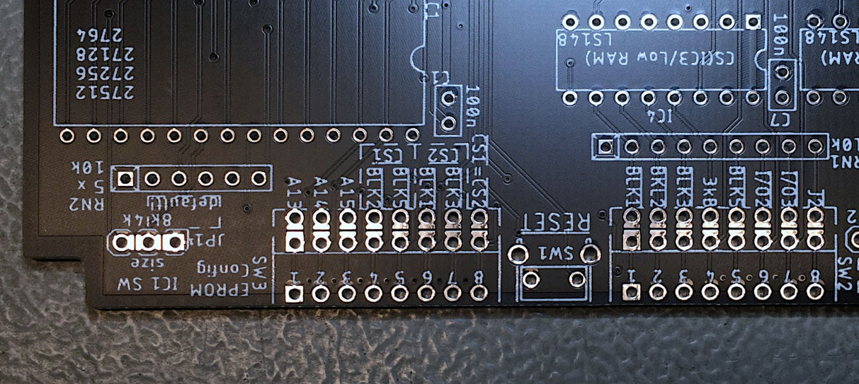

Figure 1: The footprint of the configuration DIP-switches allows a fix configuration with solder bridges

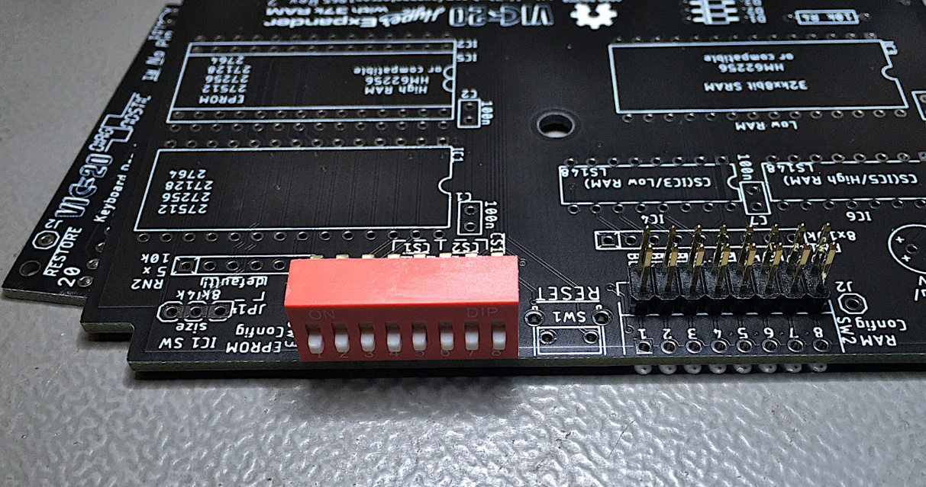

Figure 2: Vertical DIP-switch (row distance 2.54mm) or configuration with jumpers

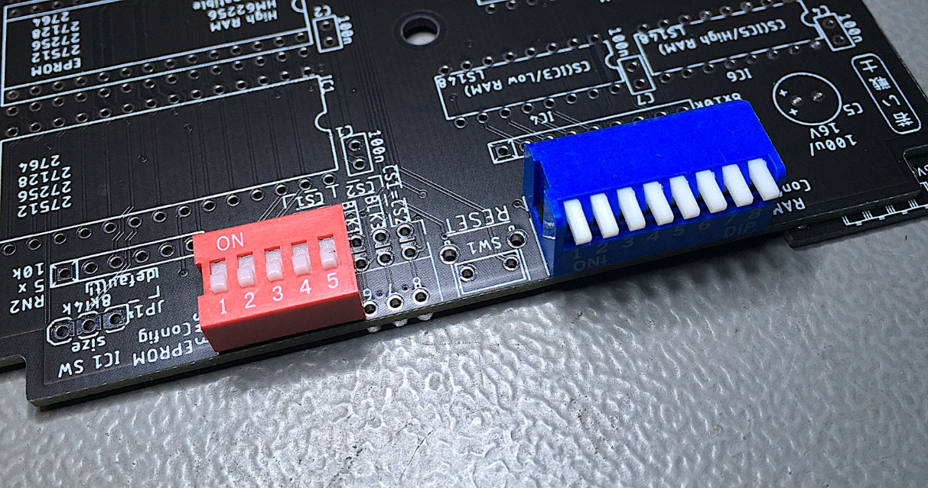

Figure 3: A horizontal or a piano style DIP-switch

## SW3 – EPROM configuration

The DIP switches do not need to be 8 switches wide, in case just one EPROM is used (refer to Figure 3). In this case, only a 5 switches wide model is sufficient. For a mere EPROM cartridge, it would be a good idea to program software that uses the same chip select (*) (or the same two chip selects for a 16k cartridge) and configure those with solder bridges. This way, the cartridge cannot be misconfigured.*

|  |  |  |  |
| --- | --- | --- | --- |
| Switch | Function | VIC-20 Address | Note |
| SW3-1 | EPROM Bank Select A13 |  | Selects 8k Bank |
| SW3-2 | EPROM Bank Select A14 |  | Selects 8k Bank |
| SW3-3 | EPROM Bank Select A15 |  | Selects 8k Bank |
| SW3-4 | IC1 chip select | $4000 - $5FFF |  |
| SW3-5 | IC1 chip select | $A000 - $BFFF |  |
| SW3-6 | IC2 chip select | $2000 - $3FFF |  |
| SW3-7 | IC2 chip select | $6000 - $7FFF |  |
| SW3-8 | = |  | All effect both ICs |

Table 1: EPROM configuration

In case all four of the previous chip selects should be configured to address one of the EPROMs, switch 8 (“= “) could be closed. In this case, both chip selects are tied together. **It is only allowed to activate one chip select!** This configuration is desired, in case both RAMs are placed and EPROM software residing at $2000 or $6000 is contained in IC1.

The mapping of the chip selects to the ICs are inherited from the original Super Expander. They support the known 16kB cartridge configurations. Hence, they are not in an ascending sequence on the DIP switch.

In case an EPROM should be deactivated, it is only required to switch the respective switch “off”. The chip select then is HIGH (inactive) due to pull-up resistors.

## SW3 - Memory Bank Select (EPROM)

There are two different types of addresses mentioned in this document:

* VIC-20 Address
* EPROM Offset Address

Both types must not be confused! The EPROM Offset Address is the address of the selected memory bank within (the program buffer of the EPROM). This is, where you load the different binary files to the EPROM buffer. One of those memory banks is selected with the DIP Switch SW3 (switch 1/2/3). This appears in/is mapped to the VIC-20 memory at the address determined by the chip select (see **Fehler! Verweisquelle konnte nicht gefunden werden.**).

|  |  |  |  |  |  |  |
| --- | --- | --- | --- | --- | --- | --- |
| SW3-3 | SW3-2 | SW3-1 | Address Bits | | | EPROM Address  (Offset) |
| **A15** | **A14** | **A13** | **A15** | **A14** | **A13** |
| ON | ON | ON | L | L | L | 0x0000 – 0x1FFF |
| ON | ON | OFF | L | L | H | 0x2000 – 0x3FFF |
| ON | OFF | ON | L | H | L | 0x4000 – 0x5FFF |
| ON | OFF | OFF | L | H | H | 0x6000 – 0x7FFF |
| OFF | ON | ON | H | L | L | 0x8000 – 0x9FFF |
| OFF | ON | OFF | H | L | H | 0xA000 – 0xBFFF |
| OFF | OFF | ON | H | H | L | 0xC000 – 0xDFFF |
| OFF | OFF | OFF | H | H | H | 0xE000 – 0xFFFF |

Table 2: 8k cartridges memory banks

A switch that is ON corresponds to a SET jumper, in case the cartridge is configured with jumpers instead of DIP-Switches.

For EPROMs smaller than a 27C512, the highest address pins have to be HIGH (see Table 7). To prevent these pins to accidentally be switched to LOW, the corresponding DIP-Switch pins could be clipped off.

## IC1 Software Size - JP1

The software size of IC1 can be set to 4kB. In this case, only the first 4kB of an 8kB EPROM bank is active. This may be desired, if the hyper expander (EPROM) should be combined with cartridges, that use the second 4k memory of an 8k bank, like some machine language monitor or serial cartridges do. Of course, this only works with a software, that only requires 4k, like the Super Expander software.

The address range of the EPROMs (as seen by the CPU) with JP1 set to “4k”

|  |  |
| --- | --- |
| **Chip Select** | **VIC-20 Address** |
|  | $4000 - $4FFF |
|  | $A000 - $AFFF |
|  | $2000 - $2FFF |
|  | $6000 - $6FFF |

Table 3: Address ranges with SW size (JP1) set to "4k"

The default software size is 8k. If it is desired to combine two cartridge software (like Super Expander and the VIC-MON machine language monitor, it is recommended to burn those two bin files in the same 8k block at the proper position.

## SW2 – RAM Configuration

SW2 activates the chip select signals, that are then decoded and address the respective RAM bank of IC3.

| **Switch** | Jumper | **Chip Select** | **Addresses** |
| --- | --- | --- | --- |
| SW2-1 | 1-16 |  | $2000 - $3FFF |
| SW2-2 | 2-15 |  | $4000 - $5FFF |
| SW2-3 | 3-14 |  | $6000 - $7FFF |
| SW2-4 | 4-13 |  | $0400 - $0FFF |
| SW2-5 | 5-12 |  | $A000 - $BFFF |
| SW2-6 | 6-11 |  | $9800 - $9BFF |
| SW2-7 | 7-10 |  | $9C00 - $9FFF |
| SW2-8 | 8-9 |  | Unused (experimental) |

Table 4: Settings SW2

# BYTES FREE

Be aware, that not all RAM configurations will lead to a more BASIC memory (the BYTES FREE) on switch on. The BASIC memory has to be coherent.

The memory map (screen RAM, BASIC RAM) of the VIC-20 depends on the memory expansion. It will be different for internal RAM and 3k Expansion.

| **RAM Configuration** | **BYTES FREE** |
| --- | --- |
|  | 6655 |
|  | 11775 |
| and | 11775 |
| and | 19967 |
| , and | 28159 |
| , , *, and* | 28159 |
| , , | 6655 |

Table 5: Reported BASIC RAM

RAM that is not visible as BASIC RAM can of course still be accessed. In case is selected, the lowest 3k are not visible as BASIC RAM. In case a memory gap is configured (like and *are configured, but* is missing, the BASIC RAM consists of the internal RAM and the 3k RAM expansion.

The **Super Expander** Software (in ROM) requires 136 bytes of RAM. In case this software is activated (it is associated to) the BASIC memory will be reduced by this number of bytes.

# EPROMs

Four different types/sizes of EPROMs can be used with the Super Expander II, not all settings make sense with them. Their pin out is shown in Table 6.

The effect of the settings and the recommended configurations are shown in Table 7.

|  |  |  |  |  |  |  |  |  |  |  |  |
| --- | --- | --- | --- | --- | --- | --- | --- | --- | --- | --- | --- |
| **27C64** | | | | | | | | | | | |
|  | **27C128** | | | | | | | | | |  |
|  | **27C256** | | | | | | | |  |
|  | **27C512** | | | | | |  |
|  | **SOCKET** | | | |  |
| Vpp | Vpp | Vpp | A15 | 1 | A15 | VCC | 28 | VCC | VCC | VCC | VCC |
| A12 | A12 | A12 | A12 | 2 | A12 | A14 | 27 | A14 | A14 | /PGM | /PGM |
| A7 | A7 | A7 | A7 | 3 | A7 | A13 | 26 | A13 | A13 | A13 | n.c. |
| A6 | A6 | A6 | A6 | 4 | A6 | A8 | 25 | A8 | A8 | A8 | A8 |
| A5 | A5 | A5 | A5 | 5 | A5 | A9 | 24 | A9 | A9 | A9 | A9 |
| A4 | A4 | A4 | A4 | 6 | A4 | A11 | 23 | A11 | A11 | A11 | A11 |
| A3 | A3 | A3 | A3 | 7 | A3 | /OE | 22 | /G/Vpp | /G | /G | /G |
| A2 | A2 | A2 | A2 | 8 | A2 | A10 | 21 | A10 | A10 | A10 | A10 |
| A1 | A1 | A1 | A1 | 9 | A1 | GND | 20 | /E | /E | /E | /E |
| A0 | A0 | A0 | A0 | 10 | A0 | D7 | 19 | D7 | D7 | D7 | D7 |
| D0 | D0 | D0 | D0 | 11 | D0 | D6 | 18 | D6 | D6 | D6 | D6 |
| D1 | D1 | D1 | D1 | 12 | D1 | D5 | 17 | D5 | D5 | D5 | D5 |
| D2 | D2 | D2 | D2 | 13 | D2 | D4 | 16 | D4 | D4 | D4 | D4 |
| GND | GND | GND | GND | 14 | GND | D3 | 15 | D3 | D3 | D3 | D3 |

Table 6: EPROM pin compatibility

|  |  |  |  |  |
| --- | --- | --- | --- | --- |
| EPROM | Size | A15 | A14 | A13 |
| 27C512 | 64kx8 | yes | yes | yes |
| 27C256 | 32kx8 | HIGH | yes | yes |
| 27C128 | 16kx8 | HIGH | HIGH | yes |
| 27C64 | 8kx8 | HIGH | HIGH | HIGH |

Table 7: Settings per EPROM type

In case Vpp is located at a dedicated pin (pin 1), A15 has no effect anymore. A HIGH level is recommended (switch is off). The /PGM Pin should be set HIGH. The n.c. (not connected) pin should be HIGH (with pull-up resistor) or open.

# Using parallel EEPROMs

There are ***parallel*** EPROMs, which fit into the EPROM sockets. They do not require erasing with a UV eraser, like EPROMs, but the price is higher.

Since they can be written, which is controlled by the signal, but the Super Expander II cartridge is lacking of this functionality, this signal has to be HIGH (inactive). The 28C256 has the A14 signal connected to Pin 1, which is A15 of the EEPROM socket. This is no problem, but it has to be kept in mind, that the jumper for A15 has effect on the bank select A14 of the EPROM.

|  |  |  |  |  |  |  |  |
| --- | --- | --- | --- | --- | --- | --- | --- |
| **28C64** | | | | | | | |
|  | **28C256** | | | | | |  |
|  | SOCKET | | | |  |
| n.c. | 💣A14 | 1 | A15 | VCC | 28 | VCC | VCC |
| A12 | A12 | 2 | A12 | A14 | 27 | /WE | /WE |
| A7 | A7 | 3 | A7 | A13 | 26 | A13 | n.c |
| A6 | A6 | 4 | A6 | A8 | 25 | A8 | A8 |
| A5 | A5 | 5 | A5 | A9 | 24 | A9 | A9 |
| A4 | A4 | 6 | A4 | A11 | 23 | A11 | A11 |
| A3 | A3 | 7 | A3 | /OE | 22 | /G/Vpp | /OE |
| A2 | A2 | 8 | A2 | A10 | 21 | A10 | A10 |
| A1 | A1 | 9 | A1 | GND | 20 | /E | /CE |
| A0 | A0 | 10 | A0 | D7 | 19 | D7 | D7 |
| D0 | D0 | 11 | D0 | D6 | 18 | D6 | D6 |
| D1 | D1 | 12 | D1 | D5 | 17 | D5 | D5 |
| D2 | D2 | 13 | D2 | D4 | 16 | D4 | D4 |
| GND | GND | 14 | GND | D3 | 15 | D3 | D3 |

Table 8: EEPROM pin compatibility

|  |  |  |  |  |
| --- | --- | --- | --- | --- |
| EEPROM | Size | A15 | A14 | A13 |
| 28C256 | 32kx8 | =A14 | OPEN | yes |
| 28C64 | 8kx8 | OPEN | OPEN | OPEN |

Table 9: Settings per EEPROM type

# Dimensions

The dimensions of the Hyper Expander are identical to those of the original Super Expander PCB.

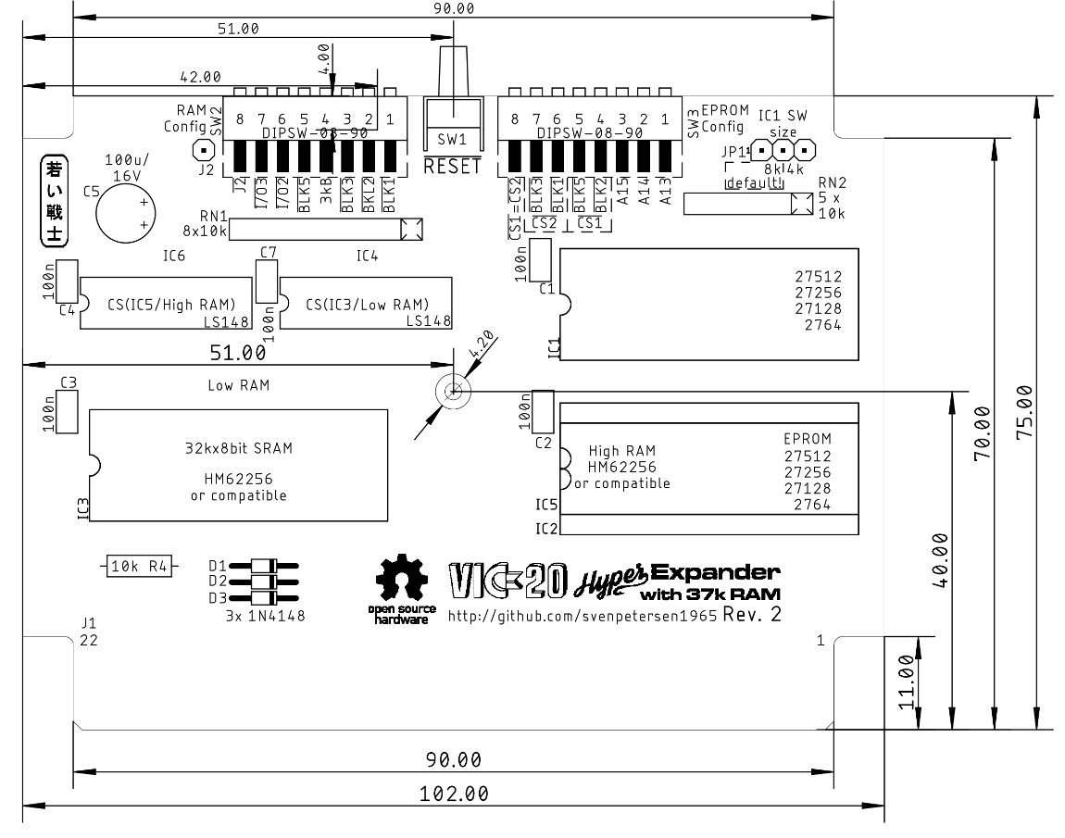

Figure 4: Dimensions of the Hyper Expander

The PCB fits the original Super Expander cartridge case, another VIC-20 cartridge case from Commodore or the [tfw8bit.com](http://www.tfw8bit.com/) cartridge case.

The VIC-20 cartridge cases are high enough to fits the Super Expander II PCB even with the ICs on sockets and vertical jumpers. This has been verified for the Super Expander case and the tfw8bit case. The tfw8bit case and the “other Commodore VIC-20” cases require two T-shaped board supports in the middle of the lower shell to be removed.

# Assembly and BOM

The High RAM (IC5) cannot be installed together with the 2nd EPROM (IC2).

## Full RAM Build

Do not place: JP2, IC2

## No RAM, just EPROM

Do not place: IC3, C3, IC4, C4, IC5, IC6, C6, RN1, D1-3, R4, SW2

# Revision History

## Rev. 0

* Prototype: Fully functional.

## Rev. 1

* Second optional RAM (IC5, “High RAM”) to provide the maximum possible RAM
* All jumpers moved to the front edge, so they can be accessed while the cartridge is installed
* Optional vertical RESET switch
* Resistor networks for many pull ups reduce the required space
* Pull ups for the EPROM chip selects

## Rev. 2

* A completely new layout
* DIP-Switch option for the jumpers
* All four *can be configured to one EPROM (by setting* = )
* The 4k Software size option for EPROM IC1